# Missing Data

## Ariel Romero

options(tidyverse.quiet = TRUE)  
library(tidyverse)  
library(VIM)

## Loading required package: colorspace

## Loading required package: grid

## Loading required package: data.table

##   
## Attaching package: 'data.table'

## The following objects are masked from 'package:dplyr':  
##   
## between, first, last

## The following object is masked from 'package:purrr':  
##   
## transpose

## VIM is ready to use.   
## Since version 4.0.0 the GUI is in its own package VIMGUI.  
##   
## Please use the package to use the new (and old) GUI.

## Suggestions and bug-reports can be submitted at: https://github.com/alexkowa/VIM/issues

##   
## Attaching package: 'VIM'

## The following object is masked from 'package:datasets':  
##   
## sleep

library(mice)

## Loading required package: lattice

##   
## Attaching package: 'mice'

## The following object is masked from 'package:tidyr':  
##   
## complete

## The following objects are masked from 'package:base':  
##   
## cbind, rbind

grades <- read_csv("class-grades.csv")

## Parsed with column specification:  
## cols(  
## Prefix = col_double(),  
## Assignment = col_double(),  
## Tutorial = col_double(),  
## Midterm = col_double(),  
## TakeHome = col_double(),  
## Final = col_double()  
## )

summary(grades)

## Prefix Assignment Tutorial Midterm   
## Min. :4.000 Min. : 28.14 Min. : 34.09 Min. : 28.12   
## 1st Qu.:7.000 1st Qu.: 80.88 1st Qu.: 83.93 1st Qu.: 52.50   
## Median :8.000 Median : 89.94 Median : 93.37 Median : 69.38   
## Mean :7.313 Mean : 85.49 Mean : 89.79 Mean : 67.70   
## 3rd Qu.:8.000 3rd Qu.: 95.00 3rd Qu.:100.56 3rd Qu.: 81.56   
## Max. :8.000 Max. :100.83 Max. :112.58 Max. :110.00   
## NA's :1 NA's :3   
## TakeHome Final   
## Min. : 16.91 Min. : 28.06   
## 1st Qu.: 69.91 1st Qu.: 52.91   
## Median : 88.42 Median : 66.11   
## Mean : 81.12 Mean : 68.23   
## 3rd Qu.: 99.07 3rd Qu.: 83.61   
## Max. :108.89 Max. :108.89   
## NA's :3 NA's :4

Task 1:

Tutorial- 1 data point missing, Midterm- 3 data points missing, TakeHome- 3 data points missing, Final- 4 data points missing.

Task 2:

vim_plot = aggr(grades, numbers = TRUE, prop = c(TRUE, FALSE),cex.axis=.7)

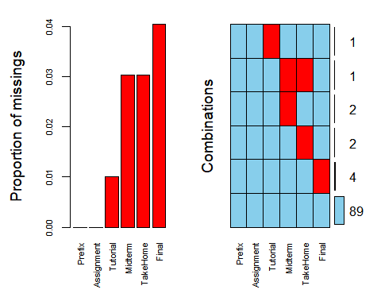

Based on the vim plot above, it appears students are missing multiple pieces of data in the Midterm and TakeHome variables.

Task 3:

gradesRowsWise = grades %>% drop_na()

After using row-wise deletion, there are 89 rows remaining in the data frame. Task 4:

gradesColWise = grades %>% select(c("Prefix","Assignment"))

After column-wise deletion, only 2 variables remain.

Task5:

For this dataset, the rows-wise deletion would be the better approach in handling the missing data. Although 10 observations are eliminated, all the variables still remain which would make for a more accurate model.

task 6:

grades_imp = mice(grades, m=1, method = "pmm", seed = 12345)

##   
## iter imp variable  
## 1 1 Tutorial Midterm TakeHome Final  
## 2 1 Tutorial Midterm TakeHome Final  
## 3 1 Tutorial Midterm TakeHome Final  
## 4 1 Tutorial Midterm TakeHome Final  
## 5 1 Tutorial Midterm TakeHome Final

#in line above: m=1 -> runs one imputation, seed sets the random number seed to get repeatable results  
summary(grades_imp)

## Class: mids  
## Number of multiple imputations: 1   
## Imputation methods:  
## Prefix Assignment Tutorial Midterm TakeHome Final   
## "" "" "pmm" "pmm" "pmm" "pmm"   
## PredictorMatrix:  
## Prefix Assignment Tutorial Midterm TakeHome Final  
## Prefix 0 1 1 1 1 1  
## Assignment 1 0 1 1 1 1  
## Tutorial 1 1 0 1 1 1  
## Midterm 1 1 1 0 1 1  
## TakeHome 1 1 1 1 0 1  
## Final 1 1 1 1 1 0

densityplot(grades_imp)

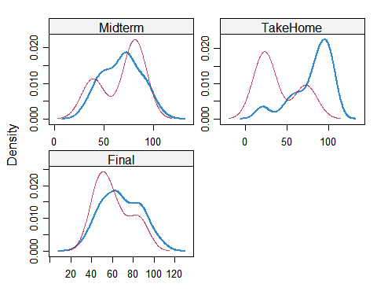

#red imputed, blue original, only shows density plots when more than 1 value the variable was imputed  
#note that the density plots are fairly uninteresting given the small amount of missing data  
grades_complete = complete(grades_imp)  
summary(grades_complete)

## Prefix Assignment Tutorial Midterm   
## Min. :4.000 Min. : 28.14 Min. : 34.09 Min. : 28.12   
## 1st Qu.:7.000 1st Qu.: 80.88 1st Qu.: 84.69 1st Qu.: 52.50   
## Median :8.000 Median : 89.94 Median : 93.10 Median : 69.38   
## Mean :7.313 Mean : 85.49 Mean : 89.76 Mean : 67.68   
## 3rd Qu.:8.000 3rd Qu.: 95.00 3rd Qu.:100.55 3rd Qu.: 81.88   
## Max. :8.000 Max. :100.83 Max. :112.58 Max. :110.00   
## TakeHome Final   
## Min. : 16.91 Min. : 28.06   
## 1st Qu.: 63.98 1st Qu.: 52.09   
## Median : 87.96 Median : 65.56   
## Mean : 79.87 Mean : 67.92   
## 3rd Qu.: 98.42 3rd Qu.: 83.61   
## Max. :108.89 Max. :108.89

Task 7:

Missing data can have a signfiicant effect on the conclusion that can be made from the data. Missing data can reduce the effectiveness the analysis being conduted, it can cause bias, and ultimately make the analysis more complicated by having to take more steps to clean the data.